VLS Certification Program Module
Detailed Design for
Manage Program Structure

<Company name>

Document Information
Author
Reviewer
Approver

Revision History
Date | Version | Author | Change Description
April 20, 2009 | 1.0 |  | All

Index
Table of Contents
1 Summary of Requirement 4
2 Proposed Solution 5
Presentation Layer 5
2.1.1 Screens / Interfaces 5
2.1.2 Reports 11
Business Layer 11
2.1.3 Manage Certification Program Structure 11
2.1.4 Sections and document references 12
Database Layer 12
2.1.5 Tables / Views 12
2.1.6 Stored Procedures / Functions 13

Summary of Requirement
User has to be provided with an option to manage the certification program with options like Add/Edit/Delete of Level/Requirement.

Proposed Solution
An option shall be provided to manage every Certification Program defined in VLS. Managing a Certification involves adding / Editing / deleting Certification Program Levels, adding / adding existing / editing / deleting Requirements. For each Requirement under each Certification Program Level, the Administrators should be able to Management Requirement Items, Pre-Requisites and Equivalencies for that particular Requirement.

Presentation Layer

Screens / Interfaces

Manage Program Structure Step By Step Screen Shots
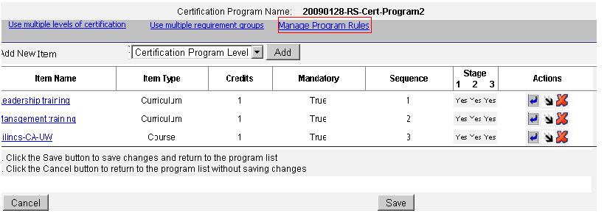

Description | - Manage program structure view for the certification program which has only requirements under it.  - Here As no levels and requirement groups exists under the certification program ‘Use multiple levels of certification’,’ Use multiple requirement groups’ Options will be shown up.  - If some levels already exist under the certification program then ‘Add levels’ option will be shown.  - If some requirement groups present under the certification program level then ‘Add Requirement Groups’ will be shown if that certification program level is having permissions to modify the requirement group. Otherwise no option will be shown to the user to change the certification program level structure.
Use Cases
User Action |  | System Response | Notes
User selects the option to have requirements directly under the Certification Program. |  | The tabs will be displayed to configure the certification program rules. | User can change the certification program structure by using the options present on the screen.
User clicks on Manage Program Rules |  | User can manage the certification program rules by configuring initial, maintenance and recertification rules.

On clicking “Use multiple levels of certification”

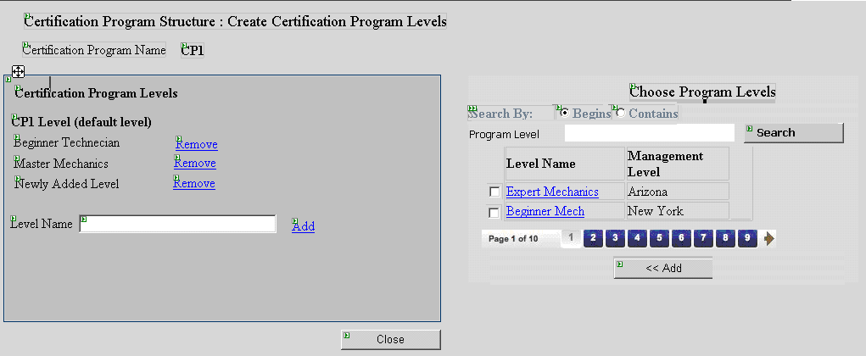

Description | - In this screen existing certification program levels will be present in one section; user can select multiple certification program levels and add them so that the certification program levels will be added to the certification program.  - User can enter the certification program level name and click on ‘add’ button to add new certification program level.  - User can remove the certification program levels after adding.  - Default Certification program level will be shown on the top of the list.
Use Cases
User Action |  | System Response | Notes
User selects ‘Use multiple levels of certification’. |  | The default level will be shown and option to add more levels under the certification program will be shown. | Default level can not be deleted.
User chooses to add existing levels |  | User can add existing levels by selecting and adding.
User chooses to add a new level. |  | A new level with name provided by the user will be added.  When user checks the existing levels and if he clicks add then levels will be saved into the database under the certification program.
User clicks on close button |  | All the data will be saved into the database.

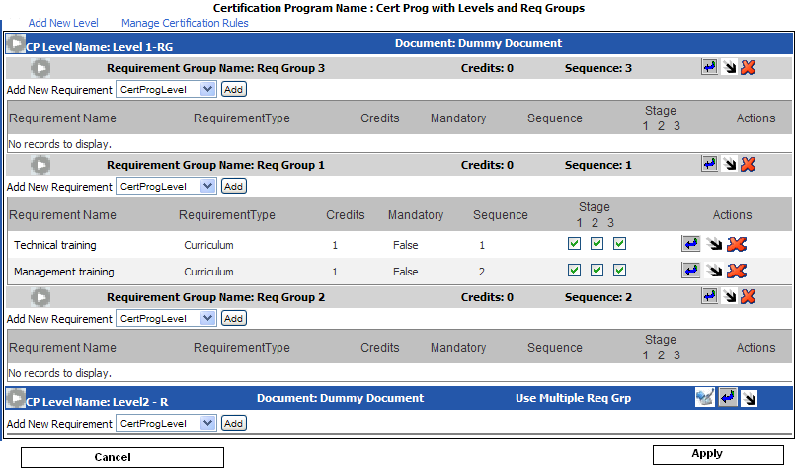
Description | Screen explains the structure of the certification program after adding certification program levels (some are existing and some are new and some are having permissions to add requirement groups and some are not).  ----Manage Requirement Equivalency icon.  ----Manage Requirement Prerequisite icon.  ----Manage Rules icon.  ----Delete icon.
Use Cases
User Action |  | System Response | Notes
User selects to have requirements directly under the program level. |  | ‘Use multiple requirement groups’ link will be shown. Manage rules icon will be displayed.
User selects to have requirement groups under the program level. |  | ‘Use multiple requirement groups’ link will not be displayed. Manage rules icon will not be displayed.

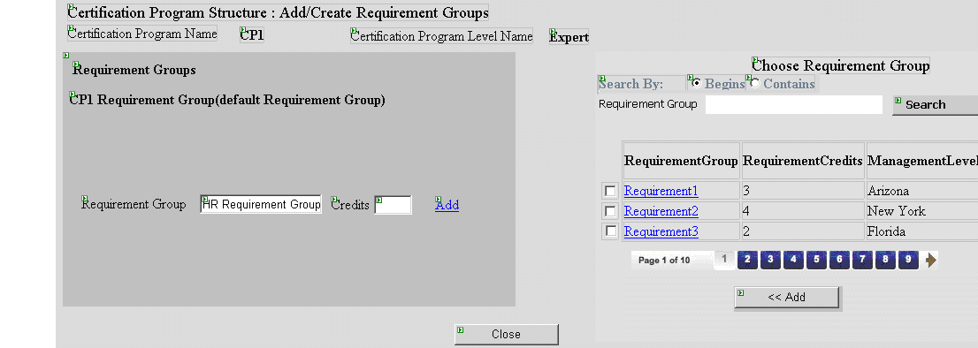

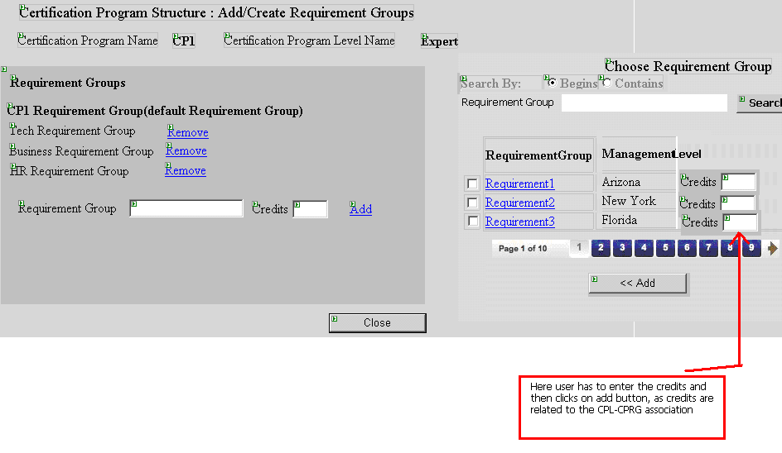

Description | • In this screen existing requirement groups will be present in one section; user can select multiple requirement groups and add them so that the requirement groups will be added to the selected certification program level.  • User can enter the requirement group name and click on 'add' button to add new requirement group.  • User can remove the requirement groups after adding.  • Default requirement group will be shown on the top of the list.
Use Cases
User Action |  | System Response | Notes
User selects ‘Use multiple requirement groups’. |  | Popup will be shown to add multiple requirement groups.
User chooses to add existing requirement groups. |  | User will check the existing requirement groups and enter the credits in the text box click add then requirement groups will be added into the database and credits will be saved.
User chooses to add a new requirement group. |  | A new requirement group with name and credits provided by the user will be added.
User clicks on close button. |  | Closes the popup and program structure page will be displayed.

Validations

- Credits Entered should be numeric.
- Sequence Entered should be numeric.

Error Situations Handling
All the errors will be handled gently and redirected to the respective error page.

Default Value Table for newly added certification program level

Field Name | Type | Value
Program Level Code | String | Empty
Active | Bool | true
Associated Certificate Document | String | None
Objective | String | Empty
Description | String | Empty
Notes | String | Empty
Allow document changes in other levels | Bool | False
Allow level changes below the management level | Bool | False

Default Value Table for newly added requirements:

Section Name | Field Name | Type | Value
Initial Certification Rules
Initial Certification Completion Deadlines | Uncertified Users: Never | Bool | true
 | Certified Users: Use uncertified users deadline | Bool | true
Initial Certification Credit Effective Date | Immediate | Bool | true
Initial Certification Expiration | Never | Bool | true
Maintenance Rules
Maintenance Start Date: Reset questions and archive scores for all courses | Never | Bool | true
Maintenance Completion Deadline | Use completion deadline settings from initial certification for <string>  Current Setting: Never | Bool | true
Maintenance Credit Effective Date | Use settings from initial certification credit effective date  Current Setting: Immediate | Bool | true
Maintenance Expiration | Use settings from initial certification expiration rules  Current Setting: Never | Bool | true
Recertification Rules
Recertification Completion Deadline | Use completion deadline settings from initial certification for | Bool | true
Recertification Credit Effective Date | Use settings from initial certification credit effective date | Bool | true
Recertification Expiration | Use settings from initial certification expiration rules | Bool | true

Validations

Validation Criteria | Field Name
Valid String Validation | Requirement Code
Valid String Validation | Requirement Level Description
Valid String Validation | Requirement is Required
Valid String Validation | Number of Times User Must Complete Requirement
Valid String Validation | Requirement Notes
Numeric Validation | Requirement Credit Value
Numeric Validation | Sequence
Date Validation  (Format: mm/dd/yyyy) | Requirement Availability :From
Date Validation  (Format: mm/dd/yyyy) | Requirement Availability :To

Reports
<Not Applicable>

Business Layer

Manage Certification Program Structure

Functionality
User can adjust credit values and sequences and can save them to database.

Name of the Object / Module | Parameters (IN) | Parameters (OUT) | Functionality of the Object / Module
DisplayStructure | <int>levelId  <int>certProgId | <CertProgramDTO>certProgDTO | Gets the all the levels, requirements under the certification program
SaveStructure | List<RequirementDTO>requirementDTOList | <bool>success | Saves credits and sequences of the level and requirements.
getExistingLevels | <int>VLSlevelId | List<CPLDTO> | Gets the list of existing certification program levels.
getRequirementGroups | <int>VLSlevelId | List<ReqGroupDTO> | Gets the list of existing requirement groups.
addRequirementGroup | <int>VLSlevelId  <RequirementGroupDTO >reqgroupDTO | <bool>success | Add the new requirement group to the certification program under the specified level.
addCertificationProgramLevel | <int>VLSlevelId  <CPLDTO>cplDTO | <bool>success | Adds new certification program level under the certification program.

Sections and document references

Section Name | Reference Document
Edit Certification Program Level | Detailed Design - VLS Certification -ManageCertificatioProgramLevels.doc
Delete Certification Program Level
Edit Requirement Group | Detailed Design - VLS Certification - Manage Requirement Groups.doc
Delete Requirement Group
Manage Requirement Groups Prerequisites | Detailed Design - VLS Certification - RequirementGroupPrerequisite.doc
Manage Requirement Groups Equivalents | Detailed Design - VLS Certification - RequirementGroupEquivalents.doc
Manage Requirements | Detailed Design - VLS Certification - ManageRequirements.doc
Edit Requirement | Detailed Design - VLS Certification - ManageRequirements.doc
Delete Requirement | Detailed Design - VLS Certification - ManageRequirements.doc
Manage Requirement Prerequisites | Detailed Design - VLS Certification - RequirementPrerequisites.doc
Manage Requirement Equivalents | Detailed Design - VLS Certification - RequirementEquivalents.doc
Certification Program Level Overview | Detailed Design - VLS Certification - ManageCertificationProgramStructureOverview.doc
Requirement Group Overview

Database Layer

Tables / Views

Entity Name | Entity Type  (T – table; V – View) | Describe the usage of the Entity
CERT_PROG | T | To store certification program details.
Cert_Program_VLSLevel | T | To store VLS level specific information.
CERT_PROG_LEVEL | T | To store certification program level details.
Cert_Prog_Level_VLSLevel | T | To store VLS level specific details of certification Program Level.
CERT_PROG_REQUIREMENT | T | To store certification program requirement details.
Cert_Prog_Level_Requirement | T | To store relationship between program level table and requirement table.
Cert_Prog_Requirement_VLSLevel | T | To store the level specific details of requirements.

Stored Procedures / Functions
Name of the Entity | Entity Type  (S – Stor. Proc.; F – Function) | Parameters (IN) | Return Value | Functionality of the Entity
SpCertGetExistingRequirementGroups | S | <int>VLSLevelId |  | Get all requirement groups under that VLS Level
SpCertSaveStructure | S | <int>level_id  <int>requirement_id  <int>credits  <int>sequence  <int>VLSLevelId | <bool>success | Save one requirement credits and sequence value.
SpCertGetStructure | S | <int>VLSLevelId  <int>Program_Id |  | Gets the structure of the certification program.
SpCertGetExistingCertificationProgramLevels | S | <int>VLSLevelId |  | Get all Certification Program Levels under that VLS Level
SPCertInsertCertProgramReq | S | <string>RequirementName  <int>Level_Id  <int>Program_Id | <bool>success | Inserts certification program requirement group into the database.
SPCertInsertCertProgramLevel | S | <string>LevelName  <int>Program_Id | <bool>success | Insert certification program level into database

